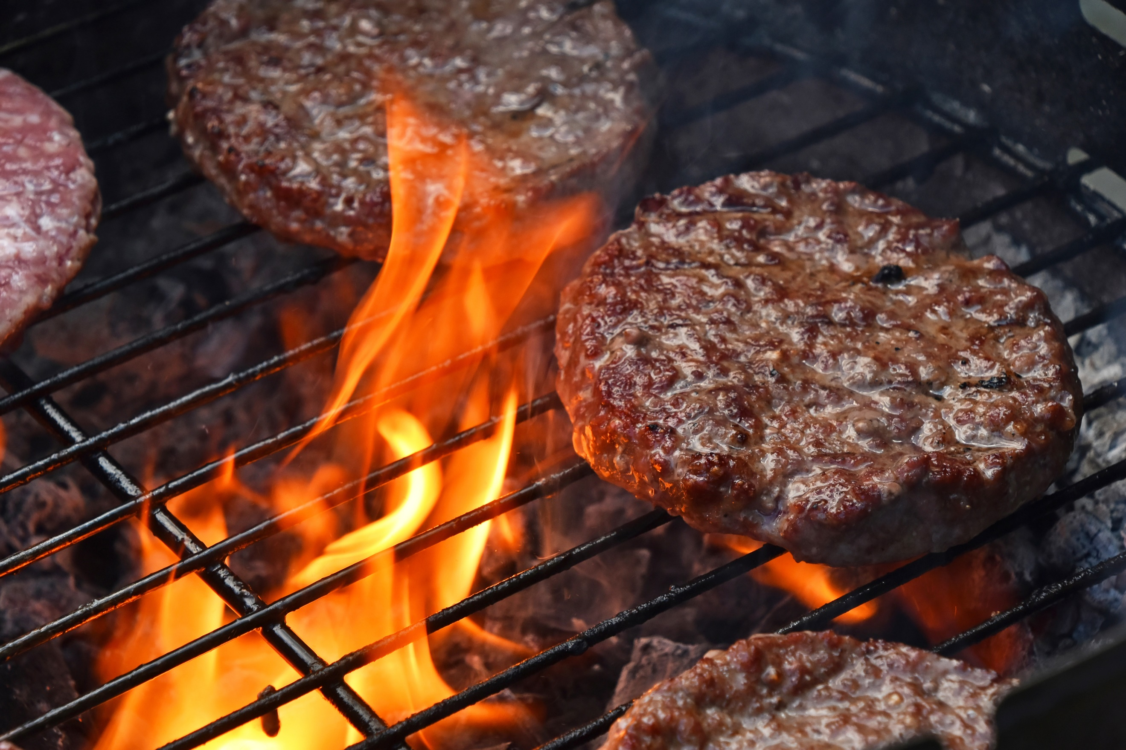
WESTSIDE GROUP
ANNUAL PICNIC
October 9, 2022 1-4pm
Medalie Park at Logan’s Landing

Burgers and Dogs Will be Served
** CONDIMENTS PROVIDED**
Lawn Games, 50/50 and Grapevine Raffles

~PLEASE BRING A DISH TO PASS~
Join us for great food, fun & fellowship!

