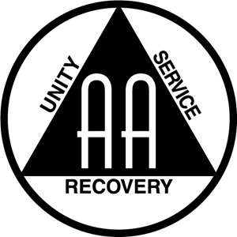

*Burgers and Hot Dogs will be provided,* ***PLEASE BRING A DISH TO PASS.***

Annual July 4th July

**This is an open event, family and kids welcome. Donations are appreciated from AA members.**

July 4th, 202212pm – 5pm **Medalie Park**  
Along South Airport Road, at Logan's Landing  
1910 S Airport Road Traverse City, MI  
Any questions please email:   
tcgroupmi@gmail.com

Please join us for: backyard games, 50/50 raffle, music, food, and more! Feel free to bring squirt guns, kites or other fun toys!

**Brought to you by: TC Group of AA**

CELEBRATION